**Email Forensic Investigation**

Header Copied: from <https://www.dropbox.com/scl/fi/dmfc4pjsm1nr77lxwdney/Practice-Acitivity-Email-Forensics.pdf?rlkey=vz7y3mo2s7tgbrkbl0biynyu8&e=1&dl=0>

Header Found:

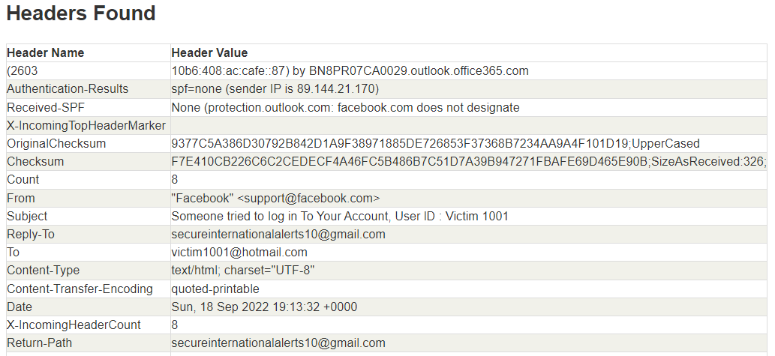

From: [support@facebook.com](mailto:support@facebook.com)  
Return path: [secureinternationalalerts10@gmail.com](mailto:secureinternationalalerts10@gmail.com)

IP Address:

